**AWESOME QR Code and Attendance Python scripts User Guide 20191201 PW**

Installation

1. Download the pre-build Python executable dist zip file (ex. awe-dist_x.y.7z).
2. Find a good place to unzip the awe-dist folder, where will be the working folder too.
3. For python programmer, please see Appendix A for module installation, and run from it.

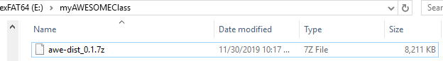

Using 7 zip, extract here to unzip the dist file. There are two subfolders, qr code and attendance update tool.

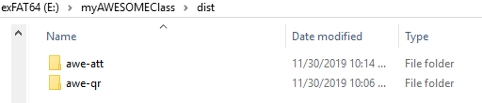

QR Code generator

1. Create a name file first, which will be used to generate the QR Code later. The awe-qr.exe will generate one QR code per line and save them as .docx file. You can use note pad (++) or any text editor to build the name list file. (ex. demo.txt)
2. Please save the name file in same folder as awe-qr.exe file, or you need to provide the path to it.
3. Open a command prompt from windows, and go to the awe-qr folder. Ex…… 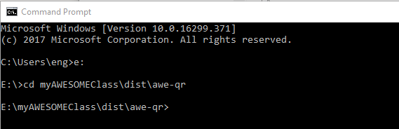
4. Ex. Run > awe-qr.exe demo.txt. The myQRStudents.docx will be created.
5. Before print out the myQRStudents.docx, make sure the name and QR image alignments are correct. If the name is too long, then the qr image may push down too far and un-aligned.

NOTE: If the output file ex. myQRStudents.docx was open, then it will have “PermissionError: [Errno 13] Permission denied: 'myQRStudents.docx'”. Please close it first, and try again.

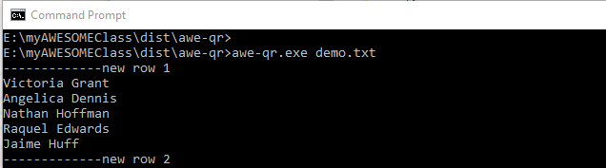

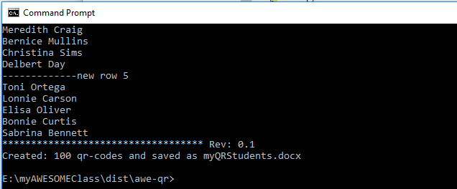

Attendance Update

1. QR code scanning suggestion: please use Excel file as scanner input file, because Excel can add a line feed after each scanning. The awe-qr.exe will generate a pure text QR code only, which is not including any extra control character. Or you can reprogram the QR scanner to add the suffix after scanning.
2. Attain the attendants’ list file, and xlsx (class file) which will be updated. Note: it must be a newer **xlsx** format.
3. There are three key words to link the update in between.
   1. “First Name”, “Last Name” in xlsx.
   2. Date in xlsx, please set cell data type to date format for the class date in xlsx

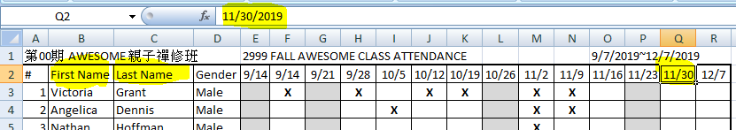

* 1. Date in attendance file. Please use **yyyy-mm-dd** format at **FIRST** Line in attendant file.

Note: If the date string is partial input (ex. yyyy-mm) , then it will find the first match column. This may cause some problems.

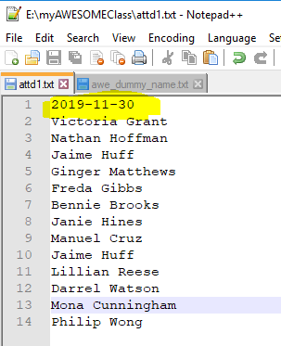

* 1. If there three key words cannot be resolved, then awe-att.exe will stop with error message.

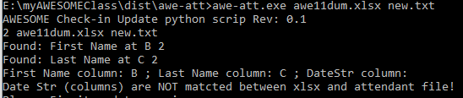

1. Run > awe-att.exe <class.xlsx> <attd.txt> to update the class.xlsx.

Note: the updates are shown on screen. Make sure to verify them correctly.

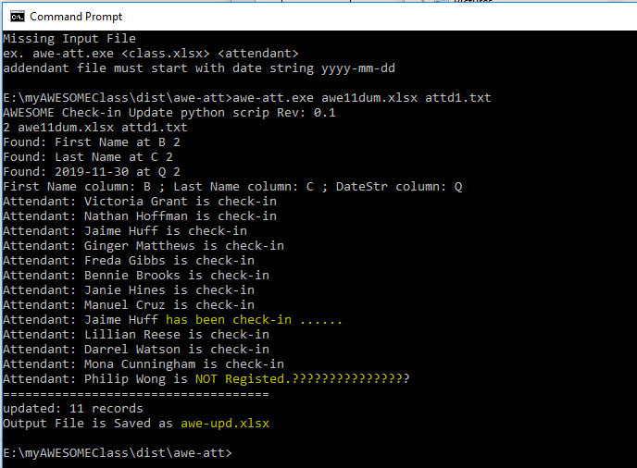

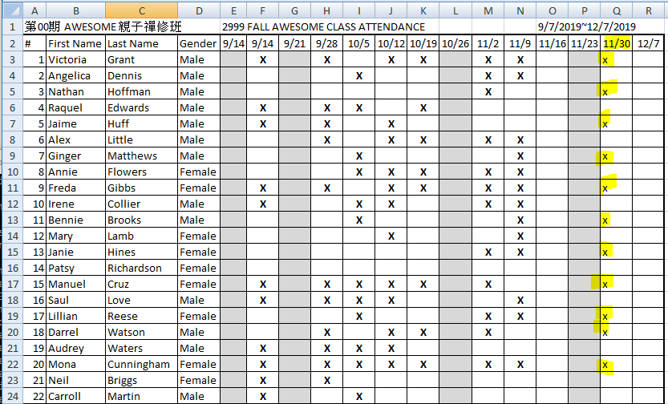

Appendix A:

Please use Python 3.5 for Windows Installation from

<https://www.python.org/downloads/windows/>

Install extra modules: such as docx, and openpyxl ..

To build the executable: pyinstaller.

Source code: <https://github.com/awesomezenphoto> coming soon..